UNIT-III

TYPES OF CIRCUIT BEAKERS

**Classification of Circuit Breakers:**

There are several ways of classifying the circuit breakers. However, the most general way of classification is on the basis of medium used for arc extinction. The medium used for arc extinction is usually oil, air, sulphur hexafluoride (SF6) or vacuum. Accordingly, circuit breakers may be classified into:

1. **Oil circuit breakers:** which employ some insulating oil (e.g., transformer oil) for arc extinction.
2. **Air-blast circuit breakers:** in which high pressure air-blast is used for extinguishing the arc.
3. **Sulphur hexafluoride circuit breakers:** in which sulphur hexafluoride (SF6) gas is used for arc extinction.
4. **Vacuum circuit breakers:** in which vacuum is used for arc extinction.

Each type of circuit breaker has its own advantages and disadvantages. In the following sections, we shall discuss the construction and working of these circuit breakers with special emphasis on the way the arc extinction is facilitated.

## Oil Circuit Breakers:

In such circuit breakers, some insulating oil (e.g., transformer oil) is used as an arc quenching medium. The contacts are opened under oil and an arc is struck between them. The heat of the arc evaporates the surrounding oil and dissociates it into a substantial volume of gaseous hydrogen at high pressure. The hydrogen gas occupies a volume about one thousand times that of the oil decomposed. The oil is, therefore, pushed away from the arc and an expanding hydrogen gas bubble surrounds the arc region and adjacent portions of the contacts (See Fig. 19.2). The arc extinction is facilitated mainly by two processes. Firstly, the hydrogen gas has high heat conductivity and cools the arc, thus aiding the de-ionization of the medium between the contacts. Secondly, the gas sets up turbulence in the oil and forces it into the space between contacts, thus eliminating the arcing products from the arc path. The result is that arc is extinguished and circuit current †interrupted.

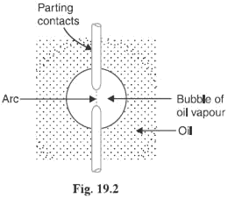

## The advantages of oil as an arc quenching medium are:

1. It absorbs the arc energy to decompose the oil into gases which have excellent cooling properties.
2. It acts as an insulator and permits smaller clearance between live conductors and earthed components.
3. The surrounding oil presents cooling surface in close proximity to the arc.

## The disadvantages of oil as an arc quenching medium are:

1. It is inflammable and there is a risk of a fire.
2. It may form an explosive mixture with air
3. The arcing products (e.g., carbon) remain in the oil and its quality deteriorates with successive operations. This necessitates periodic checking and replacement of oil.

## Types of Oil Circuit Breakers:

The oil circuit breakers find extensive use in the power system. These can be classified into the following

types:

* 1. Bulk oil circuit breakers
  2. Low oil circuit breakers

## Bulk oil circuit breakers:

Which use a large quantity of oil. The oil has to serve two purposes. Firstly, it extinguishes the arc during opening of contacts and secondly, it insulates the current conducting parts from one another and from the earthed tank. Such circuit breakers may be classified into:

1. Plain break oil circuit breakers
2. Arc control oil circuit breakers.

In the former type, no special means is available for controlling the arc and the contacts are directly

exposed to the whole of the oil in the tank. However, in the latter type, special arc control devices are employed to get the beneficial action of the arc as efficiently as possible.

## Plain Break Oil Circuit Breakers:

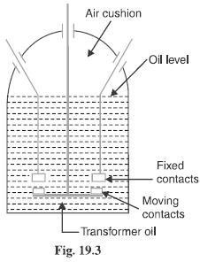A plain-break oil circuit breaker involves the simple process of separating the contacts under the whole of the oil in the tank. There is no special system for arc control other than the increase in length caused by the separation of contacts. The arc extinction occurs when a certain critical gap between the contacts is reached. The plain- break oil circuit breaker is the earliest type from which all other circuit breakers have developed. It has a very simple construction. It consists of fixed and moving contacts enclosed in a strong weather-tight earthed tank containing oil up to a certain level and an air cushion above the oil level. The air cushion provides sufficient room to allow for the reception of the arc gases without the generation of unsafe pressure in the dome of the circuit breaker. It also absorbs the mechanical shock of the upward oil movement. Fig. 19.3 shows a double break plain oil circuit breaker. It is called a double break because it provides two breaks in series.

Under normal operating conditions, the fixed and moving contacts remain closed and the breaker carries the normal circuit Current. When a fault occurs, the moving contacts are pulled down by the protective system and an arc is struck which vaporizes the oil mainly into hydrogen gas.

The arc extinction is facilitated by the following processes:

# ➢

The hydrogen gas bubble generated around the arc cools the arc column and aids the deionization of the medium between the contacts.

# ➢

The gas sets up turbulence in the oil and helps in eliminating the arcing products from the arc path.

* As the arc lengthens due to the separating contacts, the dielectric strength of the medium is increased.
* The result of these actions is that at some critical gap length, the arc is extinguished and the circuit current is interrupted.

## Disadvantages:

➢

There is no special control over the arc other than the increase in length by separating the moving contacts. Therefore, for successful Interruption, Long arc length is necessary.

# ➢

These breakers have long and inconsistent arcing times.

* These breakers do not permit high speed interruption.

Due to these disadvantages, plain-break oil circuit breakers are used only for low voltage applications where high breaking-capacities are not important. It is a usual practice to use such breakers for low capacity installations for Voltages not exceeding 11 kV.

## Arc Control Oil Circuit Breakers:

In case of plain-break oil circuit breaker discussed above, there is very little artificial control over the arc. Therefore, comparatively long arc length is essential in order that turbulence in the oil caused by the gas may assist in quenching it. However, it is necessary and desirable that final arc extinction should occur while the contact gap is still short. For this purpose, some arc control is incorporated and the breakers are then called arc control circuit breakers.

## There are two types of such breakers, namely:

1. **Self-blast oil circuit breakers**— in which arc control is provided by internal means i.e. the arc itself is employed for its own extinction efficiently.
2. **Forced-blast oil circuit breakers**— in which arc control is provided by mechanical means external to the circuit breaker.

## Self-blast oil circuit breakers:

In this type of circuit breaker, the gases produced during arcing are confined to a small volume by the use of an insulating rigid pressure chamber or pot surrounding the contacts. Since the space available for the arc gases is restricted by the chamber, a very high pressure is developed to force the oil and gas through or around the arc to extinguish it. The magnitude of pressure developed depends upon the value of fault current to be interrupted. As the pressure is generated by the arc itself, therefore, such breakers are some times called self-generated pressure oil circuit breakers.

The pressure chamber is relatively cheap to make and gives reduced final arc extinction gap length and arcing time as against the plain-break oil circuit breaker. Several designs of pressure chambers (sometimes called explosion pots) have been developed and a few of them are described below:

## Plain explosion pot:

It is a rigid cylinder of insulating material and encloses the fixed and moving contacts (See Fig. 19.4). The moving contact is a cylindrical rod passing through a restricted opening (called throat) at the bottom. When a fault occurs, the contacts get separated and an arc is struck between them. The heat of the arc decomposes oil into a gas at very high pressure in the pot. This high pressure forces the oil and gas through and round the arc to extinguish it. If the final arc extinction does not take place while the moving contact is still within the pot, it occurs immediately after the moving contact leaves the pot. It is because emergence of the moving contact from the pot is followed by a violent rush of gas and oil through the throat producing rapid extinction.

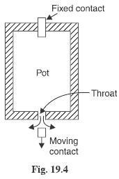

The principal limitation of this type of pot is that it cannot be used for very low or for very high fault currents. With low fault currents, the pressure developed is small, thereby increasing the arcing time. On the other hand, with high fault currents, the gas is produced so rapidly that explosion pot is liable to burst due to high pressure. For this reason, plain explosion pot operates well on moderate short-circuit currents only where the rate of gas evolution is moderate

## Cross jet explosion pot:

This type of pot is just a modification of plain explosion pot and is illustrated in Fig. 19.5. It is made of insulating material and has channels on one side which act as arc splitters. The arc splitters help in increasing the arc length, thus facilitating arc extinction. When a fault occurs, the moving contact of the circuit breaker begins to

separate. As the moving contact is withdrawn, the arc is initially struck in the top of the pot. The gas generated by the arc exerts pressure on the oil in the back passage. When the moving contact uncovers the arc splitter ducts, fresh oil is forced *across the arc path. The arc is, therefore, driven sideways into the ―arc splitters‖ which increase the arc length, causing arc extinction.

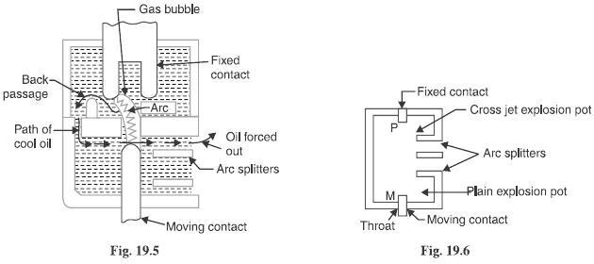The cross-jet explosion pot is quite efficient for interrupting heavy fault currents. However, for low fault currents, the gas pressure is †small and consequently the pot does not give a satisfactory operation.

## Self-compensated explosion pot:

This type of pot is essentially a combination of plain explosion pot and cross jet explosion pot. Therefore, it can interrupt low as well as heavy short circuit currents with reasonable accuracy. Fig. 19.6 shows the schematic diagram of self-compensated explosion pot. It consists of two chambers; the upper chamber is the cross-jet explosion pot with two arc splitter ducts while the lower one is the plain explosion pot. When the short- circuit current is heavy, the rate of generation of gas is very high and the device behaves as a cross-jet explosion pot. The arc extinction takes place when the moving contact uncovers the first or second arc splitter duct. However, on low short-circuit currents, the rate of gas generation is small and the tip of the moving contact has the time to reach the lower chamber. During this time, the gas builds up sufficient pressure as there is very little leakage through arc splitter ducts due to the obstruction offered by the arc path and right angle bends. When the moving contact comes out of the throat, the arc is extinguished by plain pot action.

It may be noted that as the severity of the short circuit current increases, the device operates less and less as a plain explosion pot and more and more as a cross-jet explosion pot. Thus the tendency is to make the control self- compensating over the full range of fault currents to be interrupted.

## Forced-blast oil circuit breakers:

## Image result for forced blast oil circuit breaker"

In the self-blast oil circuit breakers discussed above, the arc itself generates the necessary pressure to

force the oil across the arc path. The major limitation of such breakers is that arcing times tend to be long and inconsistent when operating against currents considerably less than the rated currents. It is because the gas generated is much reduced at low values of fault currents. This difficulty is overcome in forced-blast oil circuit breakers in which the necessary pressure is generated by external mechanical means independent of the fault currents to be broken.

In a forced -blast oil circuit breaker, oil pressure is created by the piston-cylinder arrangement. The movement of the piston is mechanically coupled to the moving contact. When a fault occurs, the contacts get separated by the protective system and an arc is struck between the contacts. The piston forces a jet of oil towards the contact gap to extinguish the arc. It may be noted that necessary oil pressure produced does not in any way depend upon the fault current to be broken.

## Advantages:

1. Since oil pressure developed is independent of the fault current to be interrupted, the performance at low currents is more consistent than with self-blast oil circuit breakers.
2. The quantity of oil required is reduced considerably.

## Low Oil Circuit Breakers:

In the bulk oil circuit breakers discussed so far, the oil has to perform two functions. Firstly, it acts as an arc quenching medium and secondly, it insulates the live parts from earth. It has been found that only a small percentage of oil is actually used for arc extinction while the major part is utilized for insulation purposes. For this reason, the quantity of oil in bulk oil circuit breakers reaches a very high figure as the system voltage increases. This not only increases the expenses, tank size and weight of the breaker but it also increase the fire risk and maintenance problems.

The fact that only a small percentage of oil (about 10% of total) in the bulk oil circuit breaker is actually used for arc extinction leads to the question as to why the remainder of the oil, that is not immediately surrounding the device, should not be omitted with consequent saving in bulk, weight and fire risk. This led to the development of low-oil circuit breaker. A low oil circuit breaker employs solid materials for insulation purposes and uses a small quantity of oil which is just sufficient for arc extinction. As regards quenching the arc, the oil behaves identically in bulk as well as low oil circuit breaker. By using suitable arc control devices, the arc extinction can be further facilitated in a low oil circuit breaker.

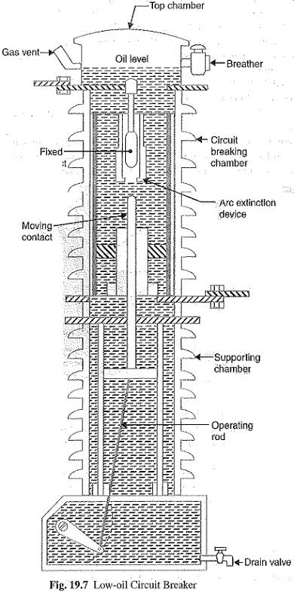

## Construction:

Fig 19.7 shows the cross section of a single phase low oil circuit breaker. There are two compartments separated from each other but both filled with oil. The upper chamber is the circuit breaking chamber while the lower one is the supporting chamber. The two chambers are separated by a partition and oil from one chamber is prevented from mixing with the other chamber. This arrangement permits two advantages. Firstly, the circuit breaking chamber requires a small volume of oil which is just enough for arc extinction. Secondly, the amount of oil to be replaced is reduced as the oil in the supporting chamber does not get contaminated by the arc.

## Supporting chamber:

It is a porcelain chamber mounted on a metal chamber. It is filled with oil which is physically separated from the oil in the circuit breaking compartment. The oil inside the supporting chamber and the annular space formed between the porcelain insulation and bakelised paper is employed for insulation purposes only.

## Circuit-breaking chamber:

It is a porcelain enclosure mounted on the top of the supporting compartment. It is filled with oil and has the following parts:

* 1. upper and lower fixed contacts
  2. Moving contact
  3. Turbulator

The moving contact is hollow and includes a cylinder which moves down over a fixed piston. The turbulator is an arc control device and has both axial and radial vents. The axial venting ensures the interruption of low currents whereas radial venting helps in the interruption of heavy currents.

## Top chamber:

It is a metal chamber and is mounted on the circuit-breaking chamber. It provides expansion space for the oil in the circuit breaking compartment. The top chamber is also provided with a separator which prevents any loss of oil by centrifugal action caused by circuit breaker operation during fault conditions.

## Operation:

Under normal operating conditions, the moving contact remains engaged with the upper fixed contact. When a fault occurs, the moving contact is pulled down by the tripping springs and an arc is struck. The arc energy vaporizes the oil and produces gases under high pressure. This action constrains the oil to pass through a central hole in the moving contact and results in forcing series of oil through the respective passages of the tabulator. The process of tabulation is orderly one, in which the sections of the arc are successively quenched by

the effect of separate streams of oil moving across each section in turn and bearing away its gases.

## A low oil circuit breaker has the following advantages over a bulk oil circuit breaker:

1. It requires lesser quantity of oil.
2. It requires smaller space.
3. There is reduced risk of fire.
4. Maintenance problems are reduced.

## A low oil circuit breaker has the following disadvantages as compared to a bulk oil circuit breaker:

1. Due to smaller quantity of oil, the degree of carbonization is increased.
2. There is a difficulty of removing the gases from the contact space in time.
3. The dielectric strength of the oil deteriorates rapidly due to high degree of carbonization.

## Maintenance of Oil Circuit Breakers:

The maintenance of oil circuit breaker is generally concerned with the checking of contacts and dielectric strength of oil. After a circuit breaker has interrupted fault currents a few times or load currents several times, its contacts may get burnt by arcing and the oil may lose some of its dielectric strength due to carbonization. This results in the reduced rupturing capacity of the breaker. There fore, it is a good practice to inspect the circuit breaker at regular intervals of 3 or 6 months.

## During inspection of the breaker, the following points should be kept in view:

➢

Check the current carrying parts and arcing contacts. If the burning is severe, the contacts should be replaced.

# ➢

Check the dielectric strength of the oil. If the oil is badly discolored, it should be changed or reconditioned. The oil in good condition should withstand 30 kV for one minute in a standard oil testing

cup with 4 mm gap between electrodes.

# ➢

Check the insulation for possible damage. Clean the surface and remove carbon deposits with a strong

and dry fabric.

# ➢

Check the oil level.

* Check closing and tripping mechanism.

## Air-Blast Circuit Breakers:

These breakers employ a high pressure *air-blast as an arc quenching medium. The contacts are opened in a

flow of air-blast established by the opening of blast valve. The air-blast cools the arc and sweeps away the arcing products to the atmosphere. This rapidly increases the dielectric strength of the medium between contacts and prevents from re-establishing the arc. Consequently, the arc is extinguished and flow of current is interrupted.

## An air-blast circuit breaker has the following advantages over an oil circuit breaker:

1. The risk of fire is eliminated.
2. The arcing products are completely removed by the blast whereas the oil deteriorates with successive operations; the expense of regular oil replacement is avoided.
3. The growth of dielectric strength is so rapid that final contact gap needed for arc extinction is very small. This reduces the size of the device.
4. The arcing time is very small due to the rapid build up of dielectric strength between contacts. Therefore, the arc energy is only a fraction of that in oil circuit breakers, thus resulting in less burning of contacts.
5. Due to lesser arc energy, air-blast circuit breakers are very suitable for conditions where frequent operation is required.
6. The energy supplied for arc extinction is obtained from high pressure air and is independent of the current to be interrupted.

## The use of air as the arc quenching medium offers the following disadvantages:

1. The air has relatively inferior arc extinguishing properties.
2. The air-blast circuit breakers are very sensitive to the variations in the rate of rise of re striking voltage.
3. Considerable maintenance is required for the compressor plant which supplies the air-blast.
4. The air blast circuit breakers are finding wide applications in high voltage installations.
5. Majority of the circuit breakers for voltages beyond 110 kV are of this type.

## Types of Air-Blast Circuit Breakers:

Depending upon the direction of air-blast in relation to the arc, air-blast circuit breakers are classified into:

1. **Axial-blast type** in which the air-blast is directed along the arc path as shown in Fig. 19.8(i).
2. **Cross-blast type** in which the air-blast is directed at right angles to the arc path as shown in Fig. 19.8 (ii).
3. **Radial-blast type** in which the air-blast is directed radially as shown in Fig. 19.8 (iii).

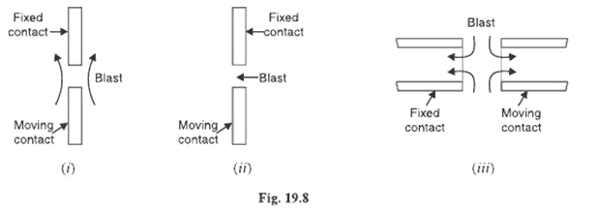

## Axial-blast air circuit breaker:

Fig 19.9 shows the essential components of a typical axial blast air circuit breaker. The fixed and moving contacts are held in the closed position by spring pressure under normal conditions. The air reservoir is connected to the arcing chamber through an air valve. This valve remains closed under normal conditions but opens automatically by the tripping impulse when a fault occurs on the system.

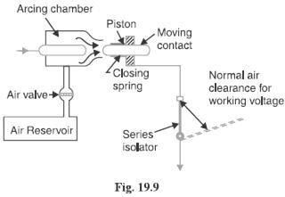

When a fault occurs, the tripping impulse causes opening of the air valve which connects the circuit

breaker reservoir to the arcing chamber. The high pressure air entering the arcing chamber pushes away the moving contact against spring pressure. The moving contact is separated and an arc is struck. At the same time, high pressure air blast flows along the arc and takes away the ionized gases along with it. Consequently, the arc is extinguished and current flow is interrupted.

It may be noted that in such circuit breakers, the contact separation required for interruption is generally small (1·75 cm or so). Such a small gap may constitute inadequate clearance for the normal service voltage. Therefore, an isolating switch is incorporated as a part of this type of circuit breaker. This switch opens immediately after fault interruption to provide the necessary clearance for insulation.

## Cross-blast air breaker:

In this type of circuit breaker, an air-blast is directed at right angles to the arc. The cross-blast lengthens and forces the arc into a suitable chute for arc extinction. Fig. 19.10 shows the essential parts of a typical cross- blast Air circuit breaker. When the moving contact is withdrawn, an arc is struck between the fixed and moving contacts. The high pressure cross-blast Forces the arc into a chute consisting of arc splitters and baffles. The splitters serve to increase the length of the arc and baffles give improved cooling. The result is that arc is extinguished and flow of Current is interrupted. Since blast pressure is same for all currents, the inefficiency at low currents is eliminated. The final gap for interruption is great enough to give normal insulation clearance so that a series isolating switch is not necessary.

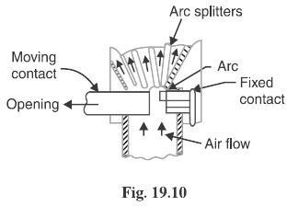

## Sulphur Hexafluoride (SF6) Circuit Breakers:

In such circuit breakers, sulphur hexafluoride (SF6) gas is used as the arc quenching medium. The SF6 is an electro-negative gas and has a strong tendency to absorb free electrons. The contacts of the breaker are opened in a high pressure flow of SF6 gas and an arc is struck between them. The conducting free electrons in the arc are rapidly captured by the gas to form relatively immobile negative ions. This loss of conducting electrons in the arc quickly builds up enough insulation strength to extinguish the arc. The SF6 circuit breakers have been found to be very effective for high power and high voltage service.

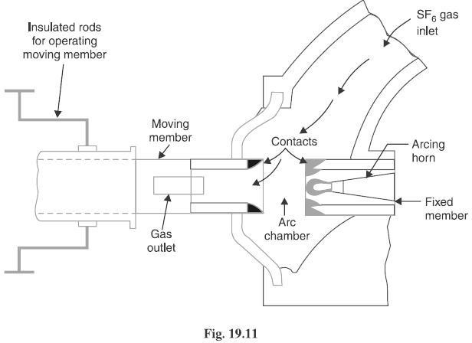

## Construction:

Fig. 19.11 shows the parts of a typical SF6 circuit breaker. It consists of fixed and moving contacts enclosed in a chamber (called arc interruption chamber) containing SF6 gas. This chamber is connected to SF6 gas reservoir. When the contacts of breaker are opened, the valve mechanism permits a high pressure SF6 gas from the reservoir to flow towards the arc interruption chamber. The fixed contact is a hollow cylindrical current carrying contact fitted with an arc horn. The moving contact is also a hollow cylinder with rectangular holes in the sides to permit the SF6 gas to let out through these holes after flowing along and across the arc. The tips of fixed contact, moving contact and arcing horn are coated with copper-tungsten arc resistant material. Since SF6 gas is Costly, it is reconditioned and reclaimed by suitable auxiliary system after each operation of the breaker.

## Working:

In the closed position of the breaker, the contacts remain surrounded by SF6 gas at a pressure of about 2·8

kg/cm. When the breaker operates, the moving contact is pulled apart and an arc is struck between the contacts. The movement of the moving contact is synchronized with the opening of a valve which permits SF6 gas at 14 kg/cm pressure from the reservoir to the arc interruption chamber. The high pressure flow of SF6 rapidly absorbs the free electrons in the arc path to form immobile negative ions which are ineffective as charge carriers. The result is that the medium between the contacts quickly builds up high dielectric strength and causes the extinction of the arc. After the breaker operation (i.e., after arc extinction), the valve is closed by the action of a set of springs.

## Advantages:

Due to the superior arc quenching properties of SF6 gas, the SF6 circuit breakers have many advantages over oil or air circuit breakers. Some of them are listed below:

1. Due to the superior arc quenching property of SF6, such circuit breakers have very short arcing time.
2. Since the dielectric strength of SF6 gas is 2 to 3 times that of air, such breakers can interrupt much larger currents.
3. The SF6 circuit breaker gives noiseless operation due to its closed gas circuit and no exhaust to atmosphere unlike the air blast circuit breaker
4. The closed gas enclosure keeps the interior dry so that there is no moisture problem.
5. There is no risk of fire in such breakers because SF6 gas is non-inflammable.
6. There are no carbon deposits so that tracking and insulation problems are eliminated.
7. The SF6 breakers have low maintenance cost, light foundation requirements and minimum auxiliary equipment.
8. Since SF6 breakers are totally enclosed and sealed from atmosphere, they are particularly suitable where explosion hazard exists e.g., coal mines.

## Disadvantages:

1. SF6 breakers are costly due to the high cost of SF6.
2. Since SF6 gas has to be reconditioned after every operation of the breaker, additional equipment is required for this purpose.

## Applications:

A typical SF6 circuit breaker consists of interrupter units each capable of dealing with currents up to 60 kA and voltages in the range of 50—80 kV. A number of units are connected in series according to the system

voltage. SF6 circuit breakers have been developed for voltages 115 kV to 230 kV, power ratings 10 MVA to 20 MVA and interrupting time less than 3 cycles.

## Vacuum Circuit Breakers (VC B):

In such breakers, vacuum (degree of vacuum being in the range from 10^-7 to 10^-5 torr) is used as the arc quenching medium. Since vacuum offers the highest insulating strength, it has far superior arc quenching properties than any other medium. For example, when contacts of a breaker are opened in vacuum, the interruption occurs at first current zero with dielectric strength between the contacts building up at a rate thousands of times higher than that obtained with other circuit breakers.

## Principle:

The production of arc in a vacuum circuit breaker and its extinction can be explained as follows:

When the contacts of the breaker are opened in vacuum (10 to 10 torr), an arc is produced between the contacts by the ionization of metal vapours of contacts. However, the arc is quickly extinguished because the metallic vapours, electrons and ions produced during arc rapidly condense on the surfaces of the circuit breaker contacts, resulting in quick recovery of dielectric strength. The reader may note the salient feature of vacuum as an arc quenching medium. As soon as the arc is produced in vacuum, it is quickly extinguished due to the fast rate of recovery of dielectric strength in vacuum.

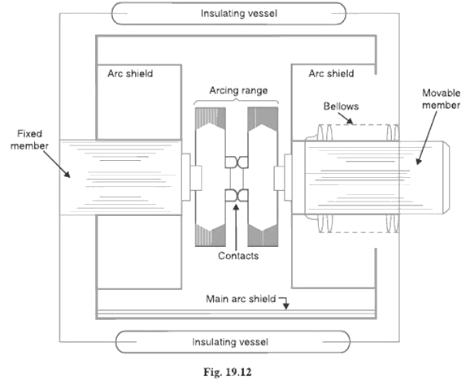

## Construction:

Fig. 19.12 shows the parts of a typical vacuum circuit breaker. It consists of fixed contact, moving contact and arc shield mounted inside a vacuum chamber. The movable member is connected to the control mechanism by stainless steel bellows. This enables the permanent sealing of the vacuum chamber so as to eliminate the possibility of leak. A glass vessel or ceramic vessel is used as the outer insulating body. The arc shield prevents the deterioration of the internal dielectric strength by preventing metallic vapours falling on the inside surface of the outer insulating cover.

## Working:

When the breaker operates, the moving contact separates from the fixed contact and an arc is struck between the contacts. The production of arc is due to the ionization of metal ions and depends very much upon the material of contacts. The arc is quickly extinguished because the metallic vapours, electrons and ions produced during arc are diffused in a short time and seized by the surfaces of moving and fixed members and shields. Since vacuum has very fast rate of recovery of dielectric strength, the arc extinction in a vacuum breaker occurs with a short contact separation (say 0·625 cm).

## Vacuum circuit breakers have the following advantages:

1. They are compact, reliable and have longer life.
2. There is no generation of gas during and after operation.
3. They can interrupt any fault current. The outstanding feature of a V C B is that it can break any heavy fault current perfectly just before the contacts reach the definite open position.
4. They require little maintenance and are quiet in operation.
5. They have low arc energy.
6. They have low inertia and hence require smaller power for control mechanism.

## Applications:

For a country like India, where distances are quite large and accessibility to remote areas difficult, the installation of such outdoor, maintenance free circuit breakers should prove a definite advantage. Vacuum circuit breakers are being employed for outdoor applications ranging from 22 kV to 66 kV. Even with limited rating of say 60 to 100 MVA, they are suitable for a majority of applications in rural areas.

## Circuit Breaker Ratings:

A circuit breaker may be called upon to operate under all conditions. However, major duties are imposed on the circuit breaker when there is a fault on the system in which it is connected. Under fault conditions, a circuit breaker is required to perform the following three duties:

1. It must be capable of opening the faulty circuit and breaking the fault current.
2. It must be capable of being closed on to a fault.
3. It must be capable of carrying fault current for a short time while another circuit breaker (in series) is clearing the fault.

Corresponding to the above mentioned duties, the circuit breakers have three ratings viz.

1. Breaking capacity
2. Making capacity and
3. Short-time capacity.

**Breaking capacity**: It is current (r.m.s.) that a circuit breaker is capable of breaking at given recovery voltage and under specified conditions (e.g., power factor, rate of rise of restriking voltage).

The breaking capacity is always stated at the r.m.s. value of fault Current at the instant of contact separation. When a fault occurs, there is considerable asymmetry in the fault current due to the Presence of a d.c. component. The d.c. component dies away rapidly, a typical decrement factor being 0·8 per cycle. Referring to

Fig. 19.24, the contacts are separated at DD´ At this instant, the fault current has

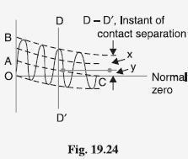

x = maximum value of a.c. component y = d.c. component

Symmetrical breaking current = r.m.s. value of a.c. component = x/√2

Asymmetrical breaking current = r.m.s. value of total current =√((x/√2)2+y2)

It is a common practice to express the breaking capacity in MVA by taking into account the rated breaking current and rated service voltage. Thus, if I is the rated breaking current in amperes and V is the rated service line voltage in volts, then for a 3-phase circuit,

Breaking capacity = √3 *rated voltage in KV *rated current in KA

In India (or Britain), it is a usual practice to take breaking current equal to the symmetrical breaking current. However, American practice is to take breaking current equal to asymmetrical breaking current. Thus the American rating given to a circuit breaker is higher than the Indian or British rating.

It seems to be illogical to give breaking capacity in MVA since it is obtained from the product of Short- circuit current and rated service voltage. When the short-circuit current is flowing, there is only a small voltage across the breaker contacts, while the service voltage appears across the contacts only after the current has been interrupted. Thus MVA rating is the product of two quantities which do not exist simultaneously in the circuit.

Therefore, the agreed international standard of specifying breaking capacity is defined as the rated symmetrical breaking current at a rated voltage.

## Making capacity:

There is always a possibility of closing or making the circuit under short circuit conditions. The capacity of a breaker to ―make‖ current depends upon its ability to withstand and close successfully against the effects of electromagnetic forces. These forces are proportional to the square of maximum instantaneous current on closing. Therefore, making capacity is stated in terms of a peak value of current instead of r.m.s. value.

*The peak value of current (including d.c. component) during the first cycle of current wave after the closure of circuit breaker is known as making capacity.*

It may be noted that the definition is concerned with the first cycle of current wave on closing the circuit breaker. This is because the maximum value of fault current possibly occurs in the first cycle only when maximum asymmetry occurs in any phase of the breaker. In other words, the making current is equal to the maximum value of asymmetrical current. To find this value, we must multiply symmetrical breaking current by

√2 to convert this from r.m.s. to peak, and then by 1·8 to include the ―doubling effect‖ of maximum asymmetry. The total multiplication factor becomes √2 X 1·8 = 2·55.

Making capacity =2·55 X Symmetrical breaking capacity

## Short-time rating:

It is the period for which the circuit breaker is able to carry fault current while remaining closed. Sometimes a fault on the system is of very temporary nature and persists for 1 or 2 seconds after which the fault is automatically cleared. In the interest of continuity of supply, the breaker should not trip in such situations. This means that circuit breakers should be able to carry high current safely for some specified period while remaining closed i.e., they should have proven short-time rating. How ever, if the fault persists for duration longer than the specified time limit, the circuit breaker will trip, disconnecting the faulty section.

The short-time rating of a circuit breaker depends upon its ability to withstand The electromagnetic force effects and The temperature rise.

The oil circuit breakers have a specified limit of 3 seconds when the ratio of symmetrical breaking current to the rated normal current does not exceed 40. However, if this ratio is more than 40, then the specified limit is 1 second.

## Normal current rating:

It is the r.m.s. value of current which the circuit breaker is capable of carrying continuously at its rated frequency under specified conditions. The only limitation in this case is the temperature rise of current-carrying parts.

**TESTING OF CIRCUIT BREAKERS:**

### Type Tests of Circuit Breaker

Type tests are conducted for the purpose of proving the capabilities and confirming the rated characteristic of the circuit breaker. Such tests are conducted in the specially built testing laboratory. Type tests can be broadly classified as the mechanical performance test, thermal test, dielectric or insulating test, short circuit test for checking the making capacity, breaking capacity, short time rating current and operating duty.

**Mechanical Test** – It is mechanical ability type test involving the repeated opening and closing of the breaker. A circuit breaker must open and close at the correct speed and perform its designated duty and operation without mechanical failure.

**Thermal Test** – Thermal tests are carried out to check the thermal behavior of the circuit breakers. The breaker under test deal with the steady-state temperature rises due to the flow of its rated current through its pole in a rated condition. The temperature rise for rated current should not exceed 40° for current less than 800A normal current and 50° for normal value of current 800A and above.

**Dielectric Test** – These tests are performed to check power frequency and impulse voltage withstand capacity. Power frequency tests are kept on a new circuit breaker; the test voltage changes with a circuit breaker rated voltage.

The test voltage with a frequency between 15-100Hz is applied as follows. (1) between poles with circuit breaker closed (2) between pole and earth with circuit breaker open, and (3) across terminals with circuit breaker open.

In impulse tests impulse voltage of specified magnitude is applied to the breaker. For outdoor circuit dry and wet tests are conducted.

**Short -Circuit Test** – Circuit breakers are subjected to sudden short-circuits in short-circuit test laboratories, and oscillograms are taken to know the behavior of the circuit breakers at the time of switching in, during contact breaking and after the arc extinction.

The oscillograms are studied with particular reference to the making and breaking currents, both symmetrical and asymmetrical restriking voltages, and switchgear is sometimes tested at rated conditions.

### Routine Tests of a Circuit Breaker

* Routine tests are also performed as per recommendations of the standards of Indian Engineering Service and Indian Standards. These tests are performed on the manufacturers’ premises. The routine tests confirm the proper functioning of the circuit breaker.
* Power frequency voltage test being the same as mentioned under the heading of type tests, the millivolt drop test is performed to determine the voltage drop within the current path of the breaker mechanism.
* Operational test is performed on the breaker by simulating its tripping by artificially closing the contacts of the relays.

### 